**What is database**



Different database engines

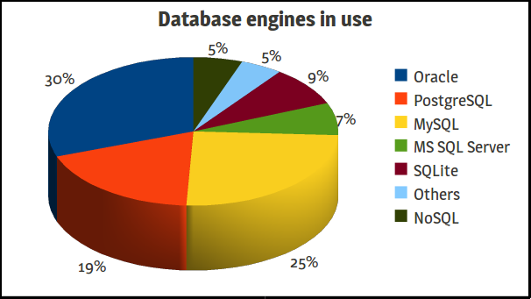

A **database**is a data structure that stores organized information. Most databases contain multiple tables, which may each include several different fields. For example, a company database may include tables for products, employees, and financial records. Each of these tables would have different fields that are relevant to the information stored in the table.  
  
Nearly all e-commerce sites use databases to store product inventory and customer information. These sites use a database management system (or DBMS), such as Microsoft Access, FileMaker Pro, or MySQL as the "back end" to the website. By storing website data in a database, the data can be easily searched, sorted, and updated. This flexibility is important for e-commerce sites and other types of dynamic websites

**What is RDBMS**

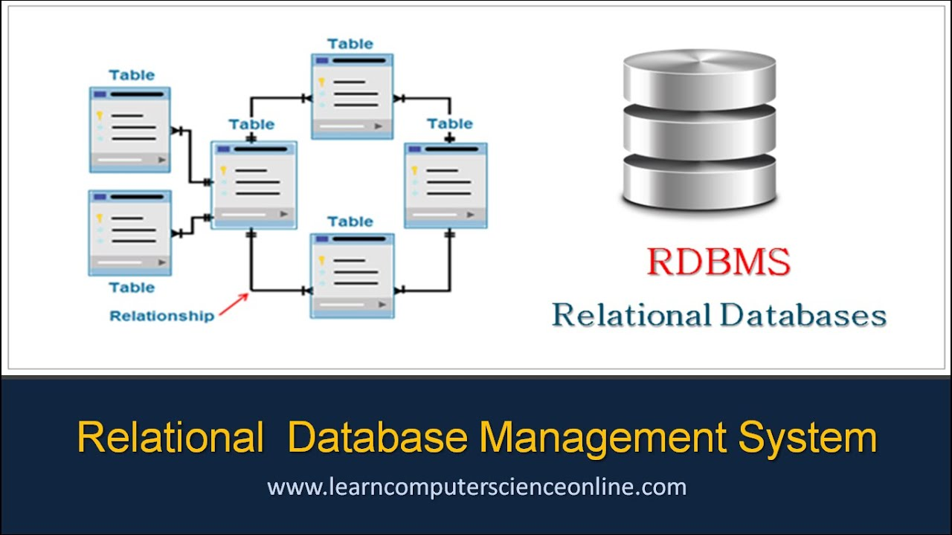

RDBMS Stands for "Relational Database Management System."

# A relational database refers to a database that stores data in a structured format, using rows and columns. This makes it easy to locate and access specific values within the database. It is "relational" because the values within each table are related to each other. Tables may also be related to other tables. The relational structure makes it possible to run queries across multiple tables at once. Structure of postgresSQL: PostgresServer    Database(It can be multiple)          Schema(It can be multiple) Inside schema we can have tables, views, triggers, indexes, sequences

# Tables of Contents:-

# 1.Data types

# 2.create, insert, update, delete, truncate tables (CURD operations)

# 3.select the data

# 4.select data using where clause, group by, having

# 5.wildcards (using LIKE operator)

# 6.CASE, alias_name,ORDER BY

# 7.Predefined functions

# 8.Operators (Arithmetic, Comparison, Logical, IN, EXISTS, BETWEEN)

# 9.Joins

# 10.Subqueries

# 11.SET operators

# 12.Constraints

# 1.Data Types

# A data type specifies what kind of data you want to store in the table field. While creating a table, for each column, you have to use a datatype. It identifies a particular type of data, like integer, Boolean, floating points, and so on.

1.Numeric datatype

2.character datatype

3.Date/Time datatype

4.Boolean datatype

**1.Numeric datatypes**

|  |  |  |
| --- | --- | --- |
| **name** | **storage size** | **range** |
| smallint | 2 bytes | -32768 to +32767 |
| **integer** | 4 bytes | -2147483648 to +2147483647 |
| **bigint** | 8 bytes | -9223372036854775808 to 9223372036854775807 |
| **decimal** | variable | up to 131072 digits before the decimal point; up to 16383 digits after the decimal point. |
| **numeric** | variable | up to 131072 digits before the decimal point; up to 16383 digits after the decimal point. |

**2. Character datatypes**

|  |  |
| --- | --- |
| **S. No.** | **Name & Description** |
| 1 | **character varying(n), varchar(n)**  variable-length with limit |
| 2 | **character(n), char(n)**  fixed-length, blank padded |
| 3 | **text**  variable unlimited length |

**3.Date/Time datatype**

| **Name** | **Size** | **Resolution** |  |
| --- | --- | --- | --- |
| Timestamp without timezone | 8 bytes | 1microsecond/14 digits |
| Timestamp with timezone | 8 bytes | 1microsecond/14 digits |
| date | 4 bytes | One day |
| Time without timezone | 8 bytes | 1microsecond/14 digits |
| Time with timezone | 12 bytes | 1microsecond/14 digits |

**4.Boolean datatype**

* True
* False

**What is precision and Scale**

NUMERIC(precision, scale)

In this syntax, the precision is the total number of digits and the scale is the number of digits in the fraction part. For example, the number **1234.567** has the precision 7 and scale 3.